**Vector Unit Test**

Vector Default constructor

Vector Copy Constructor

Vector size constructor



Vector less than 1 int constructor



Vector SetSize



Vector SetSize (lower than length)

Vector = operator

Vector copy constructor (with pointer)

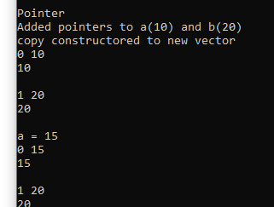

Vector of Date (reading from file to vector of date)

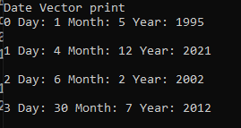

Vector of Time (reading from file to vector of time)

Negative []



Out of bounds []



**Date Unit Testing**

Param construtor, default construtor and setters, invalid param constructor

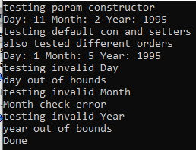

Year out of bounds

Testing month out of bounds

Testing leap year

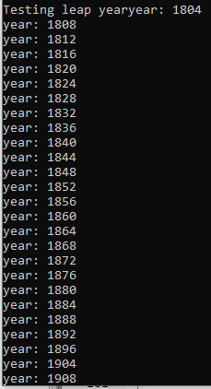

Testing Month then day setter

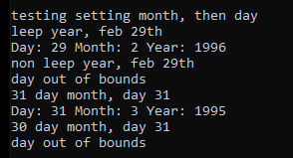

Setting Day then year

= operator and copy constructor

**Date Testing**

Default/setters and param constructor

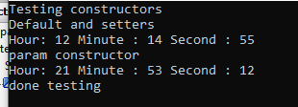

Copy constructor and = operator

Param constructor out of bound (3 tests, 1 for each)

Param constructors zeroed

Param constructors too low

Param constructors highest





**Program Testing**

File Opening

Move Data location

Text as data entry

Missing data entry

Text as year entry

Invalid year and month

Valid year, no data for month

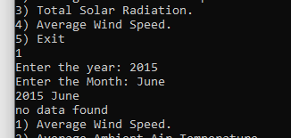

Invalid month

Invalid year

Invalid year

Invalid year

Invalid menu input

